After you successfully edit the BST class in my starter project, the program should let you enter a date, a person’s name, and ideas of what they might like for a birthday present.

After you have entered one of many such Birthday items, you should be able to enter the date on the right side of the form, click the button on the right, and retrieve the name and gift ideas. (See screen shots at end.)

Use my starter project. It contains a **Birthday class** and a **Form project** that you should **not** modify. That code is done and correct.

It also contains our **BST class** code that has the recursive add and recursive find methods. They currently store a BSTkey in the node, and find returns just true or false.

Your job is to convert the BST code. Get rid of the BSTkey. We are not going to store a simple integer. Instead, each node will store an object of type Birthday (name it BdayObject), so add that to the BSTnode class definition. You must also modify the BSTnode class’s constructor to accept a Birthday object instead of an integer which it then uses to set the value of the BdayObject.

Now modify the Add and Find methods to walk the BST tree making decisions based on the current node’s BdayObject.Date property instead of on the node’s BSTkey (which it no longer has).

In the Find method, you also have to change it to return the node’s BdayObject instead of true, and where it currently returns false, replace that with

throw new ApplicationException("no such date");

You do not have to catch the exception, just throw it.

I am considering this sort of a midterm test. It still is just one 10 point homework that gets averaged with your other homeworks, but I will be willing to give you only hints, I will not debug your programs. You need to work hard and make sure you understand how the code works, and then make the changes.

Make sure you enter at least 4 birthdays, and then remove 4, checking that the data is correct. Here are screen shots of me adding just 2:

Add the first

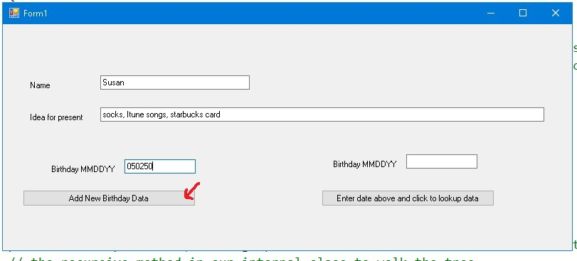

Add the second

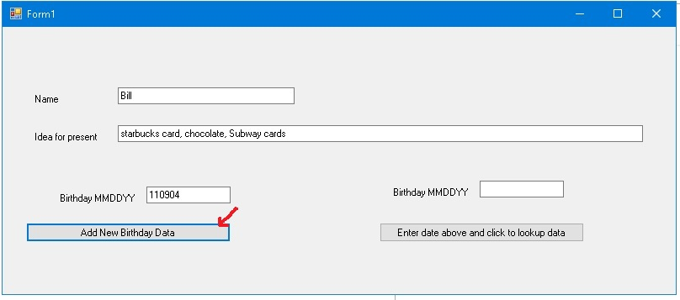

Retrieve the first

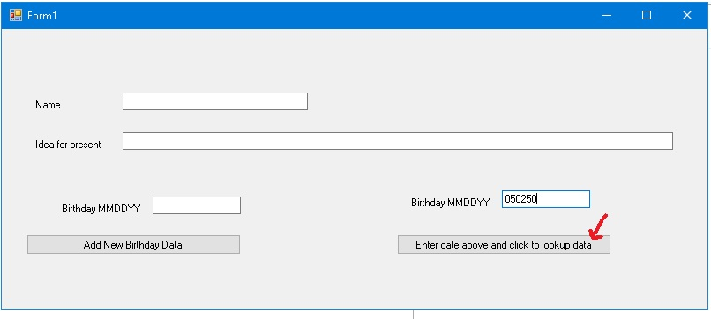

Results

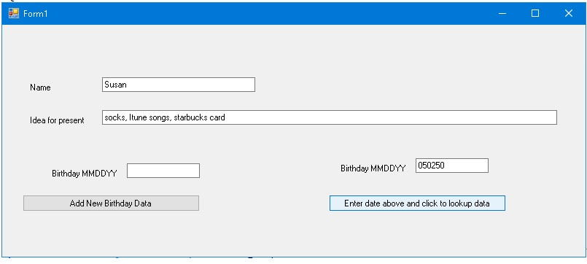

Retrieve the 2nd

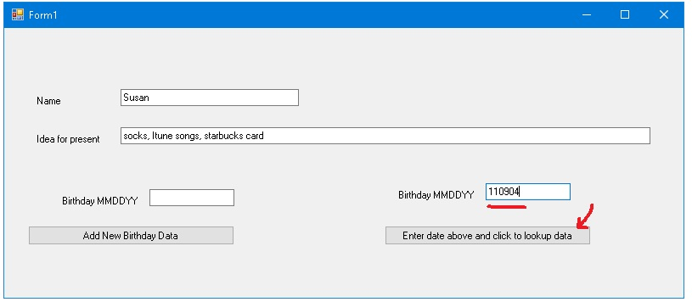

Results

